Biosis 2012 internal launch communication

Slide 1

Biosis 2012
Breaking new ground in ecology & heritage consulting

Slide 2

Back to Basics

Biosis 2012 stems from some clear business aims.

- Build a stable foundation thorough sound practice and financial management
- Advance Biosis 2012 across Australia – build brand awareness
- Support our staff and offices in growth and development
- Improve our quality through improved systems
- Control our risks with analysis and planning
- Sustainable people and profits to prosper now and in the future

Slide 3

Staff support

A range of initiatives, both planned and underway, designed to support staff.

- Restructure our leadership framework into management and technical streams
- Develop a new pay and rewards system
- Review and rework WLDs and develop KPIs and responsibilities
- Develop health and well being program

Slide 4

Office support

Building business or strengthening and stabilising client relationships, local offices have different objectives.

- Focus on building a client base in Brisbane
- New business support for Canberra, Sydney, Wangaratta and Wollongong
- Strengthen and stabilise Ballarat and Melbourne

Slide 5

Advance Biosis 2012

Mission:
Biosis provides high quality, objective ecology and heritage consulting services from respected technical specialists so that our clients can make timely, informed decisions around their projects.

Vision:
Biosis is the leader in ecology and heritage consulting. Its ethical team of academically qualified technical specialists, assisted by a network of high performing administrative and support staff, deliver independent, objective and scalable consulting services that are respected by clients and governments across Australia.

Slide 6

Biosis is...

- staffed by ecology and heritage technical experts, not environmental generalists;
- known for quality work, delivered in a timely manner;
- flexible and well resourced to provide scalable solutions;
- trusted by clients to be objective, proactive and impartial;
- respected, honest, insightful, professional.

Slide 7

Key themes in our communication

- Biosis is an ethical, trustworthy company.
- Biosis engenders confidence; its work helps clients make sound decisions.
- Biosis provides expertise, guidance and information to clients.
- Biosis interprets the facts for clients.
- Biosis encourages clients to think.
- Biosis provides services based on scientific findings and specific legislative knowledge.
- Biosis advice is supported by research-based facts.
- Biosis is independent; we do not advocate for any cause.
- Biosis prizes professionalism and objectivity.
- Biosis is about delivering extensive expertise as part of a complete solution for its clients.

Slide 8

Key messages in our communication

- Biosis is wise, ethical and trustworthy.
- Biosis helps clients make informed decisions about their projects.
- Biosis is in the business of researching, evaluating and reporting upon the ecology and heritage impacts of projects.
- Biosis is experienced and respected for its ability to deliver consulting expertise on demand.
- Biosis is a national presence with a strong professional network and the capability to scale up or down according to client needs.
- Biosis contributes to the development and extension of the talent pool through professional development and the award of research scholarships.
- Biosis guides its clients and leads discussion about ecology and heritage consulting.
- Biosis develops innovative procedures and systems to improve its performance.
- Biosis does not tolerate attempts to influence its objectivity or to erode its independence.

You will see these messages communicated throughout the new Biosis website.
These messages can be appropriately used within proposals and other client/potential client communication.

Slide 9

The Biosis 2012 message

Will be shared with all our clients via email.

<include excerpt of letter>

Biosis: Breaking New Ground in Ecology and Heritage Consulting
The Biosis you know is respected for our objective and timely advice on projects.
As a leader in ecology and heritage consulting within Australia, Biosis now opens a new chapter with our new corporate identity and the launch of biosis.com.au
Our new logo and online presence is not just about looking the part. For us, it’s a celebration of our past and a way of framing up and modernising our future. We’re pleased with the results because the better we communicate with our partners, the more likely we are to become involved in projects that inspire and interest us.
More importantly, when you have people like ours feeling positive about their work, you have Australia’s best ecology and heritage consultants energised and ready to work on your projects.
So, take a look at the new website. You’ll see how we’re moving forward with seven regional offices and an online presence that puts the information and contacts you need at your fingertips.
Now, no matter where you are in Australia, Biosis is there with you. Just as we have been there for more than 8000 successful projects in the infrastructure, resources, recreation, construction and water sectors.
Visit biosis.com.au for a few minutes today. We’d love to hear what you think.
Regards,

Robert Baird & Aaron Harvey
Directors
Biosis Pty Ltd

Slide 10
The Biosis 2012 message

Will be communicated via our event presence.

Event | Location | Involvement | Date | Office | Who
Biosis 2012 (launch) | Wollongong |  | late Aug | WRG
Wimmera CMA annual conference | Dimboola | Sponsorship & attendance | 6 Sept | BRG | MSG, SLA, GLT, ACAW (maybe).  Bob presenting a paper.
VPELA State Planning conference | Ballarat | Sponsorship & attendance | 6-7 Sept | BRG/MRG/WaRG | AJH & IB
Wind and Wildlife Conference | Melbourne | Sponsorship & attendance | 9-Oct | MRG | AJH, MV, IS
Biodiversity Forum | Melbourne | Sponsorship & attendance | 18-Oct | MRG | AJH & most MRG Ecology staff
Minerals conference | Wollongong | Sponsorship & attendance | 22-23 Oct | WRG | NMG, AKT, AJH & MT
EIANZ Annual Conference | Sydney | Sponsorship & attendance | 24-26 Oct | MRG/SRG | AJH, AKT & NMG
Transport Conference | Brisbane |  | Oct | BrRG | MLC
Biodiversity Forum | Sydney |  | 14-15 Nov | SRG | AJH, NMG & AKT
NSW Minerals Conference | Sydney |  | 20-Nov | SRG

Slide 11
The Biosis 2012 message and all our key brand messages

Will be communicated via our new website

www.biosis.com.au

Slides 12 – 20
<insert screen grabs of all menu tab pages, unless all RGMs could display and share the live site>
(N.B. We will provide briefing notes to the RGMs about the key aspects of the site worth highlighting and how the staff should provide feedback or thoughts, if any. Please let me know what you would like to include re the website feedback process).

Slide 12

Brand assets

You’ve seen most of the brand assets being delivered over the past weeks and months.
- Printed collateral and vehicle magnets have been delivered to all offices.
- Corporate apparel size and colour selection is taking place shortly.
- Office signage is being produced and installed in the coming weeks.
- Event support kits will display the new brand at the upcoming events for Sept, Oct and Nov.
- Your emails will also all have new email signatures.
- All of our email addresses change to <name>@biosis.com.au (but will redirect from the existing addresses for a period of time)
- The new website is now live!

Today is also about the official launch of our much anticipated internal templates....

Slide 12
Templates

- All new templates can be found on the T drive.
- Templates exist for the following:
  - Letterhead, variants by office
  - Fax header, variants by office
  - File note
  - Powerpoint presentation slides
  - Event invitation
- Every template has an associated ‘User Guide’ which can be found in pdf form together with the relevant templates in the T Drive file structure.
- User Guide content is also easily accessible on the Wiki.

Slide 13
Proposal Templates

The following proposal templates are already available on the T drive.

- NSW Ecology FF proposal (long)
- NSW Ecology letter proposal (short)
- VIC Heritage CHMP proposal (long)
- VIC Heritage letter proposal (short)

All other state variants are being created to be consistent with the above proposal templates.
The full suite of proposals will be available on the T drive by <date>.

Slide 14
Report Templates

The following report templates are already available on the T drive.

- VIC Ecology FF report
- VIC Heritage CHMP report

All other state variants and other report types are being finalised and approved.
The full suite of reports will be available on the T drive by <date>.

Slide 15
Proposal & Report Templates

There are a few things worth noting.

- Extensive work has gone into the reformatting, testing and checking of the templates.
- Each proposal and report has an associated ‘User Guide’ – please make good use of them.
- A ‘template champion’ exists in each office to assist with initial use of the new templates.
- Please remember, when copying text from another document select ‘paste special’ and ‘unformatted text’.

Slide 16
Proposal & Report Templates

Some clever initiatives have been implemented and improvements have been made.

- More professional style and layout in line with the new brand.
- The Open Sans font has been embedded in all templates so that recipients on any PC/laptop will see the document as it is intended to be displayed, regardless of whether they have Open Sans installed on their machine.
- Double columns have been removed where issues have been experienced in the past.
- Line spacing issues have been resolved.
- Section numbering and page numbering has been inserted for easier discussion with and reference by the client.
- We have found a solution that protects the integrity of the template style guides, even if people accidentally paste in formatted text from another document!

Slide 17
By changing these settings as shown below, it is impossible for anyone to paste text from another document with conflicting formatting. It will always be pasted in the normal style.

The steps to follow are provided in the User Guide and only need to be performed once by each user on each PC. Gary is also investigating a solution for applying this setting across the business centrally.

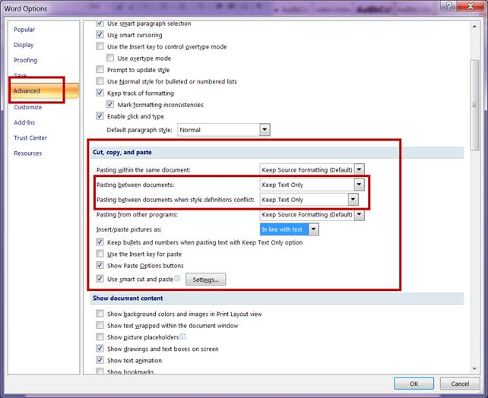

Slide 17
Thank you

Thanks for your patience as we progressed Biosis 2012.

The finishing touches will be applied over the next week or so.

We hope you experience some benefit from our improved communication tools.

We recognise there will be some teething issues as we all get used to the new templates and some of the changing processes.

